**Report**

**Topic :** Accuracy comparisons for ANN , CNN models developed from scratch for classification of mnist data set

**ANN Model :**

* Model consists of   
  **1.** Input layer (flattens images from 28 * 28 to 784*1)  
  **2**. Dense layer 1 ( takes input as 60,000 images of size 784 * 1 and outputs images of size 50 * 1 , using tanh as activation function)  
  **3**. Output layer ( takes 50 *1 as input as gives 10 * 1 as output for classification , using softmax as activation function )  
  **4**. Used SGD for optimizing the features.
* After training , Prediction using test data resulted an accuracy of **95.94** with a learning rate of 1e-2

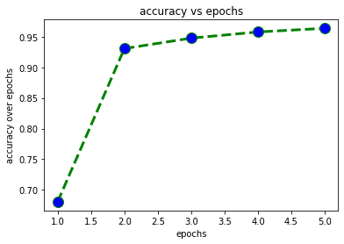

**CNN Model :**

* Model consists of   
  1. Input layer   
  2. Convolution layer ( takes images of size 1* 28 * 28 , with kernels of size 1*3*3 , outputs images of size 1 *26 * 26 uses ReLu activation function)  
  3. Flatten layer ( takes 1 * 26 * 26 images and outputs the image by flattening them to 676 * 1 )  
  4. Output layer ( takes 676 * 1 as input as outputs 10 *1 for classification uses Softmax as activation function).  
  5. Used SGD for optimizing the features.
* After training , Prediction using test date resulted an accuracy of **91.47** with a learning rate of 1e-4

**CNN + ANN Model :**

* Model consists of   
  1. Input layer   
  2. Convolution layer ( takes images of size 1* 28 * 28 , with kernels of size 1*3*3 , outputs images of size 1 *26 * 26 uses ReLu activation function)  
  3. Flatten layer ( takes 1 * 26 * 26 images and outputs the image by flattening them to 676 * 1 )  
  4. Dense layer ( takes 676 *1 as input as outputs 50 * 1 uses tanh as activation function )  
  5. Output layer ( takes 50 * 1 as input as outputs 10 *1 for classification uses Softmax as activation function).  
  6. Used SGD for optimizing the features.  
  7. After training , Prediction using test data resulted an accuracy of 92.3 % with learning rate of 1e-4

**Observations :**

* Actually , CNN should have more accuracy than ANN . Since in CNN model the dimensionality gets reduced which decreases the cost of computation of the features .
* CNN+ANN should have more accuracy then CNN .